This is a failure – with an open at the Gheen road (JA) end of the beverage. You are looking at essentially 1500 feet (electrical) of hardline with an open at the transformer. Scale is 1 us/div.

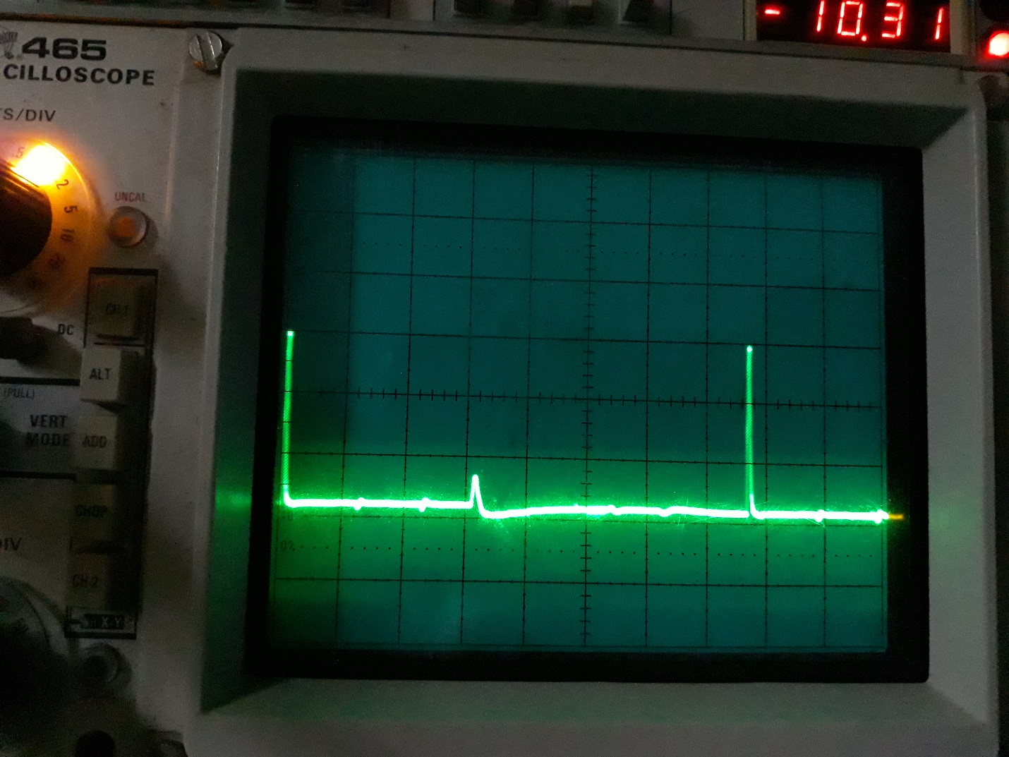

After we fixed it – this shows the complete system coming all the way back into the shack. The small bump up is the open circuit in the shack on the far end of the system. The large spike is the next pulse generated by the TDR (using the 2X position). This is looking at the JA feedline:
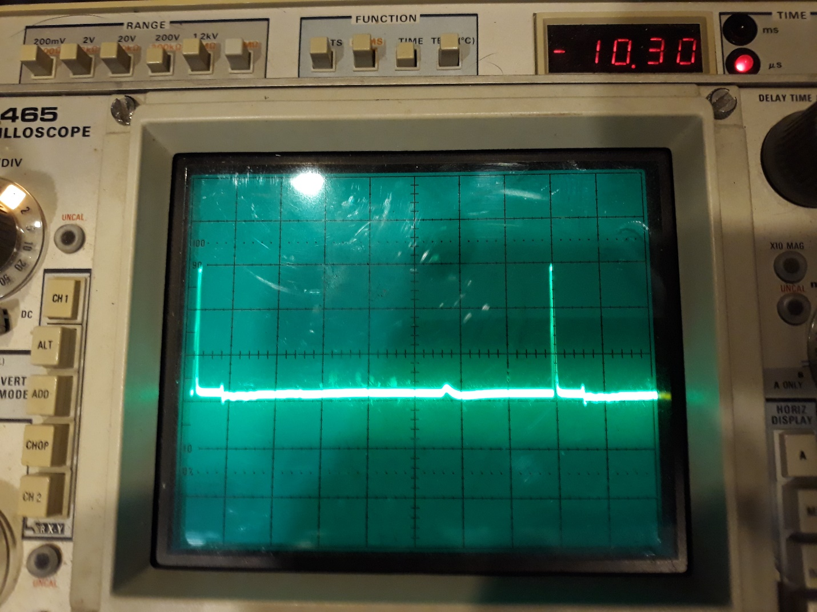
The 5.5 us distance translates to about half that for a return path – so about 2.25 us electrical – which is around 2250 feet total length electrical – or probably about 2000 feet actual with propagation delay in the hardline.

This is with the other end in the shack shorted to ground giving us a small downward blip:
