MIDWAY

This is a story about the secret Japanese radio codes; the intercept and deciphering of those by our Navy in WW-II; and the use of the radio intelligence from that to make our victory and destruction of the Japanese naval fleet at the battle of Midway in June 1942 more possible. My role in this as a Navy radioman was to be ready and trained to copy that Japanese radio code from the Farallon Islands just off the coast of San Francisco, thus in the continental U.S. in CA and not at Midway nor on a battleship.
I didn’t know what the Japanese radio messages said, but copied their radio signals and wrote down the corresponding Japanese symbols, for our Navy’s translation and use.

My interest in writing this story is as an example of a contribution made towards helping win the war without having been on a battleship or airplane or beachhead, where many men and women showed so much bravery and sacrifice.

The word code has several meanings in this story. One use of this word is to refer to morse code, used by radio operators to send radio messages by dots and dashes. Another meaning is as in the Japanese secret radio codes. Secret codes are used to send information intended to be understood by only a certain audience. Ancient civilizations did this with cave or stone carvings. In WW-II our military utilized the Navajo soldiers as code talkers to send secret messages by voice. The Japanese sent some diplomatic messages by electronically scrambled voice, which were generally easy to decipher. The vast majority of Japanese wartime messages were sent by short wave radio using morse code of dots and dashes. The patterns of the dots and dashes corresponded to the Katakana characters of the Japanese language involved.

There are many different sets of characters used for Japanese writing. These may be somewhat like complex Chinese characters, or as Katakana characters. The complex characters are not suitable for radio transmission, and the 46 Katakana characters are used. These characters have equivalents of symbols, short English letter equivalents, or for radio transmission 46 different sets of dots and dashes. The radio intercept operator hears the dots or dashes in morse code, and then transcribes that by copying those Katakana symbols by hand onto paper. On the paper the symbols are written to begin in the upper right corner of the paper, then continue downward in that first column, and in a similar fashion in columns to the left. This was commonly known as copying the Japanese code. The operator does not know the meaning of these coded messages, but sends those off to be deciphered. That radio intelligence is then forwarded to the fleet commanders to improve their chances in a naval battle. A few of the Katakana symbols are illustrated below. In this example the English equivalents and morse code equivalents are also included. The word Honolulu is used, and written in the downward vertical column as HO NO RU RU. There is no L Katakana character. The example also shows that a message could be sent in plain language and be readable by those knowing that language. In wartime the messages would be sent with scrambled characters, then being able to be quickly decoded by the Japanese, or by our Navy with much difficulty.

- 1 -

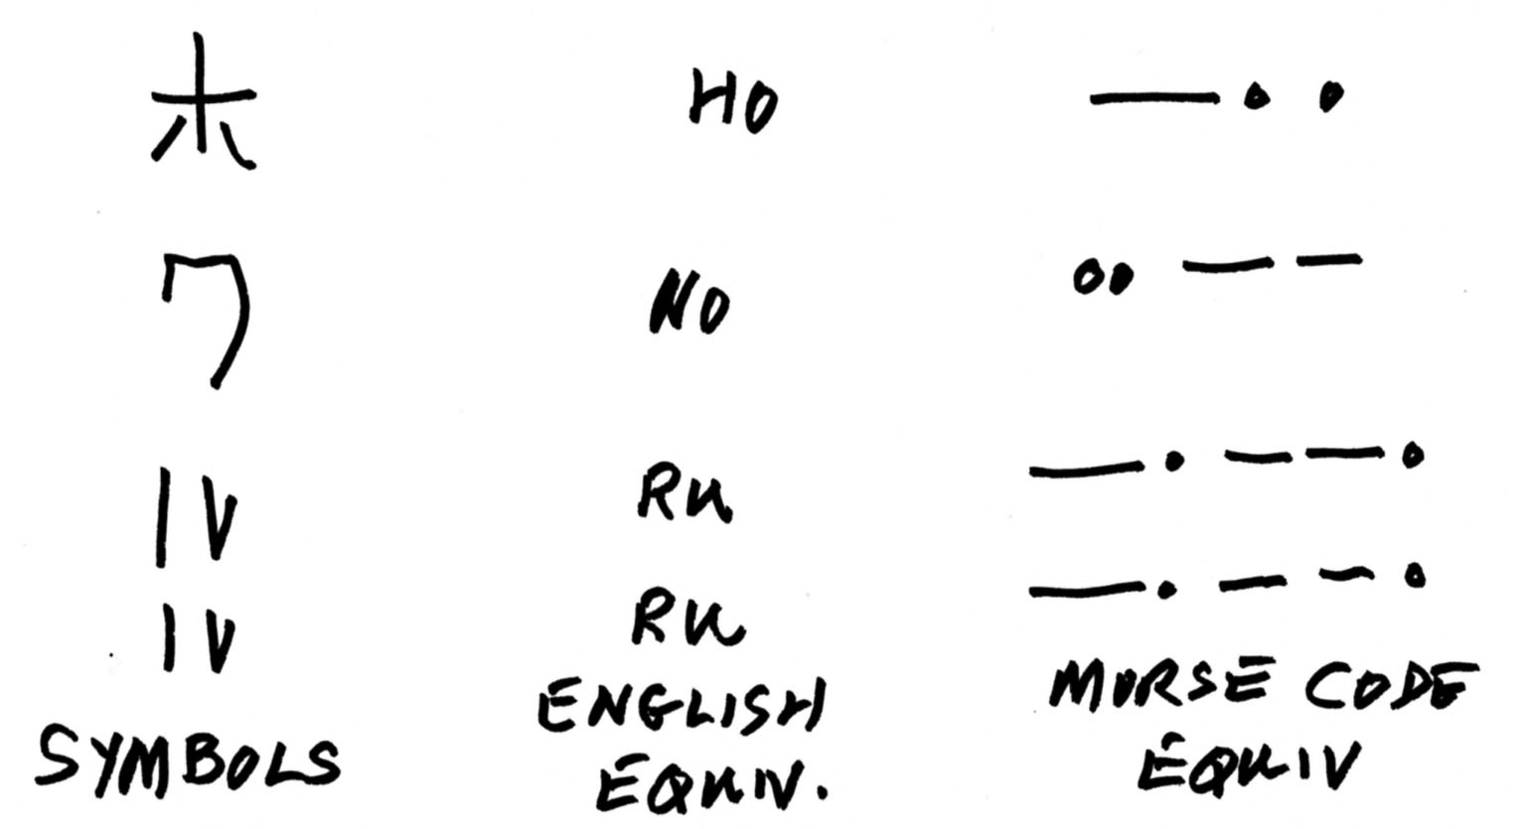

The secret aspects of these events of 68 years ago, have been declassified for many years, and are described in many books. The best book that I have found on these subjects was by Rear Admiral Edwin Layton, title: “And I Was There, Pearl Harbor and Midway, Breaking the Secrets”, published in 1985, and copyright for the Layton estate by Konecky and Konecky of Old Saybrook, CT. They have given me permission to use extracts from that book in this story.

Some extracts of Layton’s book follow.

The Naval battle of Midway June 4th, 1942 was a turning point towards winning WW-II in the Pacific against the Japanese.

The leadership and strategy of Admiral Nimitz with the U.S. aircraft carriers, Navy airplanes and brave pilots under his command made this possible.

Admiral Nimitz had the advantage of having radio intelligence information from our radio intercept of the Japanese code, and the decoding of that. His belief that the intercept information was accurate allowed him to reach Midway before the battle, and to prepare for that.

Layton, p405, paragraph one. Nimitz trusts Rochefort’s work and results with the Japanese code messages. Rochefort was brilliant with deciphering the Japanese code and may have been one of the most important persons in the Navy with radio intelligence information towards the success at Midway.

Paragraph two. Hypo (the code facility in Hawaii) and those in Washington had many serious personality conflicts, resulting in the lack of vital information being sent back to Hawaii. This could have had an effect at Pearl Harbor, and dispels the myth about knowing of the Pearl Harbor attack ahead of time.

p411. Rochefort figured out that the characters AF in Japanese messages were shorthand meaning Midway. He also had some information in messages about the Japanese battle plans for Midway.
- 2 –
The Hypo crew devised and sent some messages about a fictional failure of the water system on Midway. Following that with several messages back and forth by both the Japanese and Ameicans, Rochefort was able to decode more important information regarding the Japanese Midway battle plans and dates.

Layyton’s book in chapters 32 and 33 give the most interesting views about the battle of Midway, both before and during that event. The U.S. Navy decoders had an office sign that read “You don’t have to be crazy to work here, but it helps”. Rochefort and his decoders used 3 million IBM cards a month, as this was before computers. He analyzed 140 messages a day, and could recall information or clue about a code back among the scattered boxes of IBM cards from months earlier. This was all by the amazing ability of his mind instead of a computer hard disk. His code unit Hypo kept trying to pinpoint the estimated date of the attack on Midway. They believed it was between 2 and 4 June, which was correct, but in conflict with the mid June date believed by admirals in Washington. It was imperative for Nimitz and the U.S. fleet to arrive near Midway before the attack. It was only the belief by Nimitz in the accuracy of Rochefort’s radio intelligence that the day was saved. Of course there were many more other decisions than radio intelligence made by U.S. commanders that were also important.

Layton’s chapters on the actual battle are extremely interesting but too long to repeat here. Briefly the U.S. Navy made good decisions and plans and few errors, in contrast with the Japanese errors. It wasn’t easy – Japan had 145 warships, to our 35.
War is hell. The Japanese had lost four carriers, one cruiser, 2,500 men, and 322 aircraft.
We paid a price too, 347 lives, one carrier, a destroyer, and 147 aircraft. Of course there were other big losses at Pearl Harbor, Pacific fighting, and in Europe and Africa.

Midway is a 2.4 square mile atoll, NW of the Hawaiian Islands. There are three islands with a total of 1500 acres, within a 15,000 acre lagoon. Midway is about half way between North America and Asia. In the 1940s the U.S. viewed Midway as an important defense post, and defenses there were improved. The islands are home to about 3 million birds, and 250 marine life species nearby.
-3 -

How did I happen to do this work, or be prepared for that? I started getting ready at age 12. My father brought home a radio magazine then that showed how to build a simple radio. It had a radio part called a coil, made from wire, and that was wound onto an oatmeal box. It included other simple parts, one small tube, and some batteries.
I would listen to it by the hour and hear radio morse code of dots and dashes sent from commercial or Navy stations near and far. Eventually I could tell a dot from a dash, and then that three dots and a dash was the letter V, which was often sent many times before the radio station sent their call sign. I had many notebooks in which I recorded those call signs. All of this whetted my appetite for radio and engineering and the start of a career in electrical engineering and radio communications. Along the way I discovered amateur radio as a hobby and service where we communicate by morse code or voice to other amateurs all over the world. By 1937 at age 16 I took the exam in SF for the radio amateur license, and received the call W6PBV. By then I had built a 3 tube better receiver, and had bought a used transmitter for $50 by working in a grocery store for $2 a day. I was soon contacting far off places like Manchuria.

In our lives we have many mentors. One in San Mateo, CA, where I lived during the above time, was Doc Redeker. He was our radio instructor at the Junior College, but also a Captain in the Naval Reserve. He encouraged and helped many of us young guys to join the local Naval Reserve Unit in San Mateo. There we attended meetings and classes and learned the Navy message procedures. Our other mentor was Dave Baker, W6WX, who was our instructor. I started in that Naval Reserve unit as a radioman third class, Rm3c, and later in the Navy reached Rm1c. I was in the Navy five years during WW-II from Feb. 1941 to January 1946, all in the continental United States primarily in radio intelligence work. Later after Midshipmans school and staying in the Naval Reserve, I became an officer as LtCmdr.

We jump ahead to Feb 14th 1941. The Navy called me to active duty to operate their radio station NPG in San Francisco. My Navy duty was at their headquarters in SF to operate their morse code circuit 8 hours a day. In one shift I might handle 180 messages, sometimes typing those on an old typewriter or sometimes sending with a radio key called a bug (which is sent by hand to make dots and dashes). I was prepared to immediately take over this very important assignment and task at age 19 due to my radio experience since age 12, the Naval Reserve training in San Mateo, and my ability as an amateur radio operator.
I always feel that some of us have been given special talents, and mine were great ability with morse code, and with typing (I was 26 lessons ahead of my highschool typing class).

- 4 -

The Navy radio station NPG was the headquarters to serve and control Navy communications in the entire Pacific and western North America, and we were in contact with Navy ships in the Pacific, and Navy shore stations in Hawaii NPM, Guam, Canal Zone, Phillipines, Seattle, San Diego, etc. For big shore radio stations the headquarters; transmitters (that send out the morse code), and the receiving stations are usually in separate locations, to not cause interference between locations.
The NPG transmitters were at Mare Island near Vallejo, north of SF. I had a telephone line to that, and if I needed more radio power to contact the Phillipines I could call up and ask for more – the radiomen at the transmitter site could then bring up a 50,000 watt transmitter to do the job. Amateur radio transmitters are limited to 1,500 watts.
NPG had many radio operators, each to contact certain ships or areas. Each operator had a separate circuit with a separate radio channel or frequency and a separate receiver and transmitter and antenna. In the operating room was a small conveyer belt to deliver messages to be dropped off to the operator of a certain circuit. The operator could also use the belt to add messages that he had copied, to be on their way for proper distribution or action. On transmit he would validate each such message by his shorthand notation and date with one hand while sending with the other hand. A few rare operators could copy or send a message and carry on a voice conversation with someone at the same time. I never achieved or had that ability, but could send or receive for hours or an entire shift without error. This was important as many messages were encoded with five letter code groups in English letters.

. Sometime in 1941 I was transferred to the Farallon Islands, 30 miles off shore from SF, and about 20 miles distant from Pt. Reyes in Marin County. Describing those islands is a whole story in itself, for another time. The Spanish called those the pointed rocks. The Navy callsign there was NPI. At that time it was part of a direction finding system to help ships enter the Golden Gate and not pile up on the rocks of the Farallones. The system had 3 stations, one NPI on the Farallones, one NLG at Pt Reyes, and a third one north of Half Moon Bay, NMC at Montara. Japanese commercial ships were welcome at that time, and from NPI I would get a message from one of their ship radio operators: “Please Mr. NPI, can you give us a bearing? The three Navy or Coast Guard stations would take bearings to the ship, and we would determine their location and advise them of that. The direction finder system there used an amateur radio receiver the National HRO, and a special direction finder antenna. This was all mounted in the second story of a silo type building. We could measure bearings of distant ships or stations to about one degree.

The Pearl Harbor attack occurred on December 7th 1941. Everything changed after that. Soon I was sent to Bainbridge Island Washington, near Seattle, to learn the Japanese code. I was sent back after that to the Farallones to copy the Japanese code from their ships and shore stations, and to give estimates of their bearings. This was before, during, and after the battle of Midway.

THIS WAS MY MOST IMPORTANT WW-II CONTRIBUTION.
- 5 -
Sometime soon after the above effort from the Farallon Islands, the Navy had other assignments for me. The first one was to send me to Marin County CA, with another navy radioman, Bud Gearhart. We lived in Inverness in a rented house on main street between the post office and the local bar, but our Navy duty was nearby at the AT&T radio receiving station near Pt. Reyes CA. This was on the Pacific coast overlooking the ocean with a giant antenna farm of huge rhombic antennas. It was a quiet location with no radio noise so that we could receive the faintest radio signals from Japan or elsewhere. We used another amateur radio receiver, the Hammarlund SuperPro.
Our duty was to receive and record diplomatic radio traffic from Japan sent to Rome or South America or elsewhere. Radio reception was outstanding at such a location and facility, and you could hear a pin drop radiowise. The messages were scrambled but in a very old fashioned simple manner, and our boss Lt Ray Kempf had designed and built electronics to unscramble those messages. We sent that information on to the Navy for them to forward to our state department for diplomatic radio traffic.

The Navy kept me on the move. They next sent me to the Two Rock Ranch an Army radio facility near Petaluma CA. There were just two of us Navy personnel there, to teach radio intelligence work.

I next heard about the Navy V12 program. That was to send some sailors to a university to obtain an engineering degree, then become a Navy officer, and so be trained for further duty. One of the Navy yeoman (secretary to you) at the SF headquarters let me know of the V12 program and said he could help me to apply for that. There were two openings for radiomen from the entire 12th Naval District. I was selected for one of those and sent to CalTech in Pasadena, where I worked toward a BSEE degree which I received in 1945. I was then sent to Notre Dame for Midshipmens school and became an Ensign. Then returned to CA again to Long Beach Navy yard and taught radio until discharged in January 1946.

At the time of ending Naval active duty, I received a letter from Simon Ramo. He was forming the electronics division of Hughes Aircraft, and had three engineers at the time. The letter offered me a position there to be the fourth engineer. I turned it down for a variety of reasons. It was another turning point in my life.

- 6 –

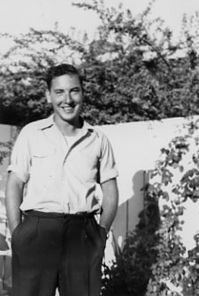
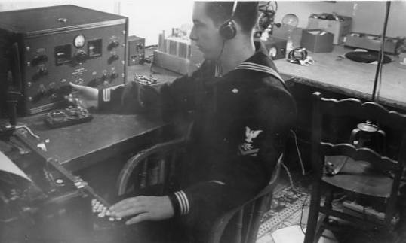
Bob Leo Radio Operator then
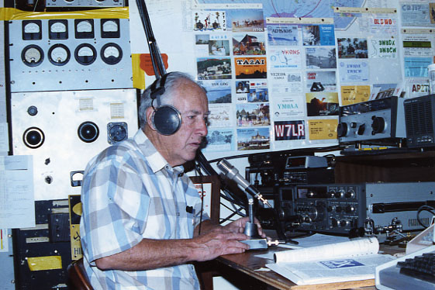
Bob Leo age 19 ready for NPG

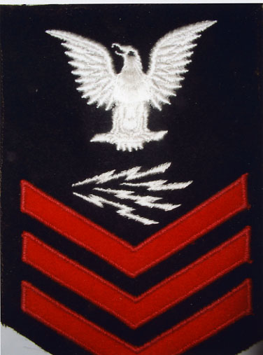
W7LR Radio Operator Today
Rm1c
-7-

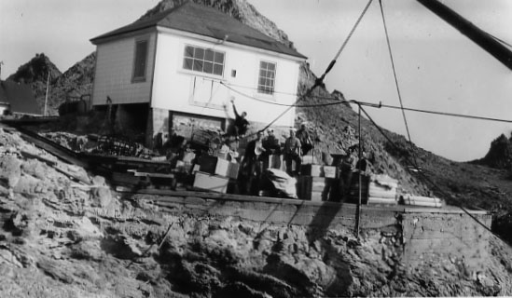
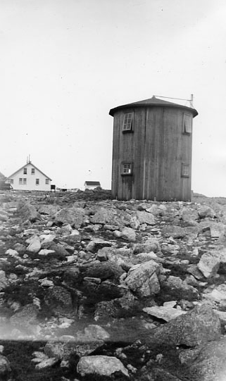
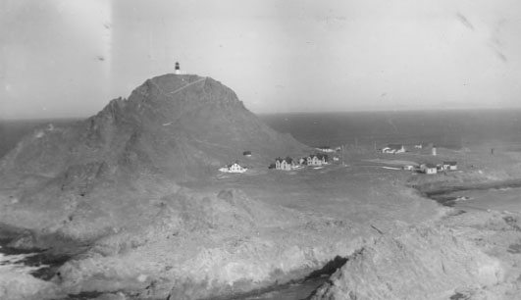
Farallon Island
Unloading the Boat
Direction Finding Silo
-8-

List of books:

The Complete Story of Codebreaking in World War II, Stephen Budiansky, Simon and Schuster, 2000

And I Was There, Pearl Harbor and Midway, Breaking the Secrets, Rear Admiral Edwin T. Layton, 1985

Miracle at Midway, Gordon Prange, 1982, Penguin Books

The Farallon Islands, Peter White, 1995, Scottwall Associates

QST amateur radio, October 1943, page 31, The Japanese Morse Radiotelegraph Code, Charles Holden, ARRL, Newington, CT

Maritime Radio Historical Society, Radio Compass Station NLG, Pt Reyes, CA

www.omniglot.com, Japanese Katakana description

some of my Navy records

The Code Breakers, David Kahn, New American Library, 1973

The American Black Chamber, Herbert O. Yardley, Copyright 1931, Ballantine Books, NY. especially Japanese Secret Codes.

The Japanese Morse Telegraph Code, Donald Millikin, QST, p23, Sept. 1942

Also, RELAY, Dec 1942; and RADIO, May 1941 (neither located).

Robert Leo, Bozeman, MT July 31st, 2010 revised August 22nd, 2010

W7LR, w7lr@aol.com

- 9 -

